**Sanzida Parvin**

**Data Visualization**

When me with my family lived in Seattle, we struggled a lot to cope up with the rainy gloomy days during the winter. Then I heard that the suicide rate in the USA is highest in Seattle area due to the gloomy rainy weather. This shocking news interested me to find out some actual figures on Suicide rates and/or numbers.

For this visualization project I have chosen the suicide dataset from Kaggle. The full dataset has 27820 observations with 12 variables. The observations consisted of the data about 100 countries all over the world. For this project I have filtered out only the USA data. Few questions that were addressed in the project are shown below.

1. Total number of Suicides among the countries. Male vs Female

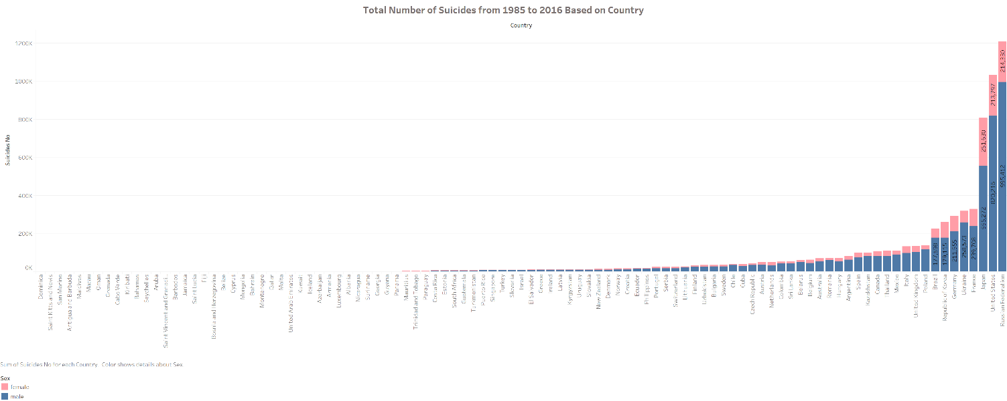

From the figure it is shown that the United States is the second top country based on suicidal rate. So, I was trying to find some pattern inside the USA only. After applying the filter in Tableau, the next few scenarios were found out.

1. Total number of male vs female suicides according to years

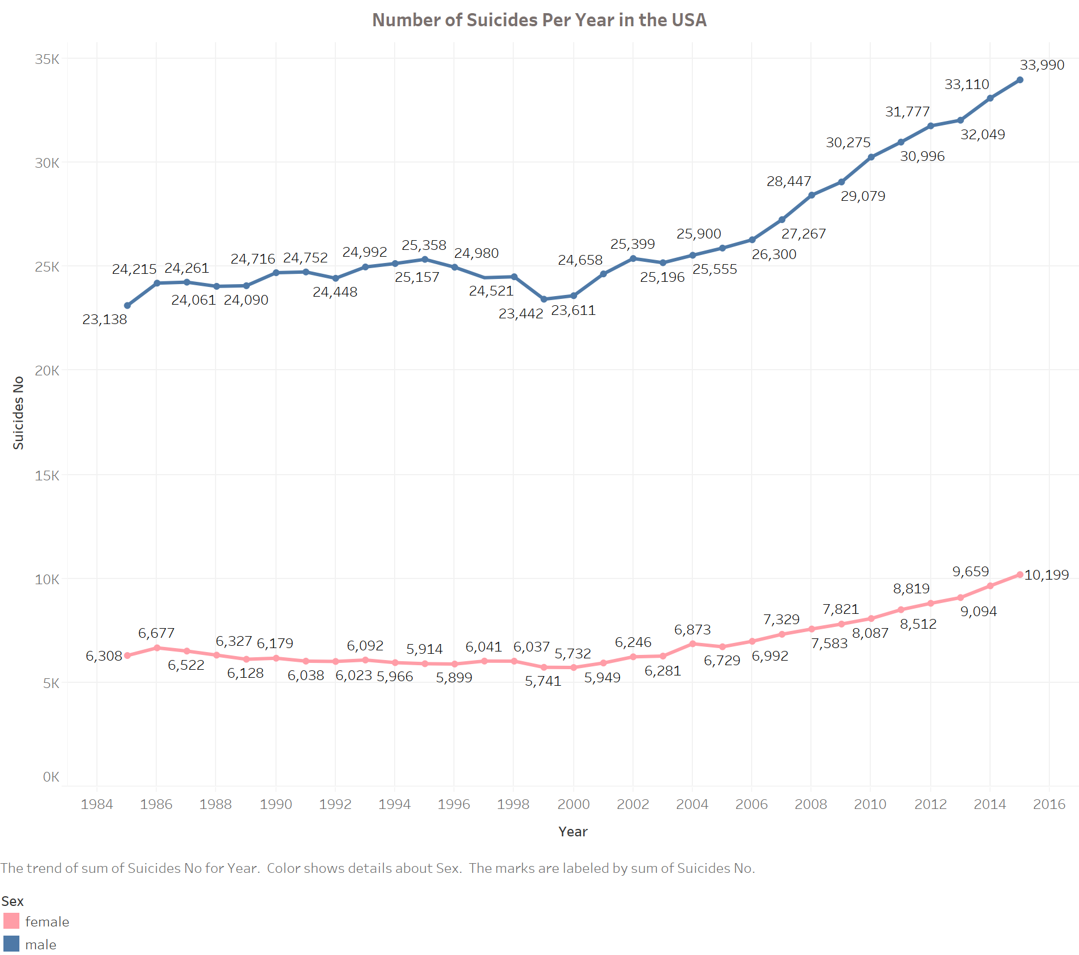

1. Number of suicides according to age group

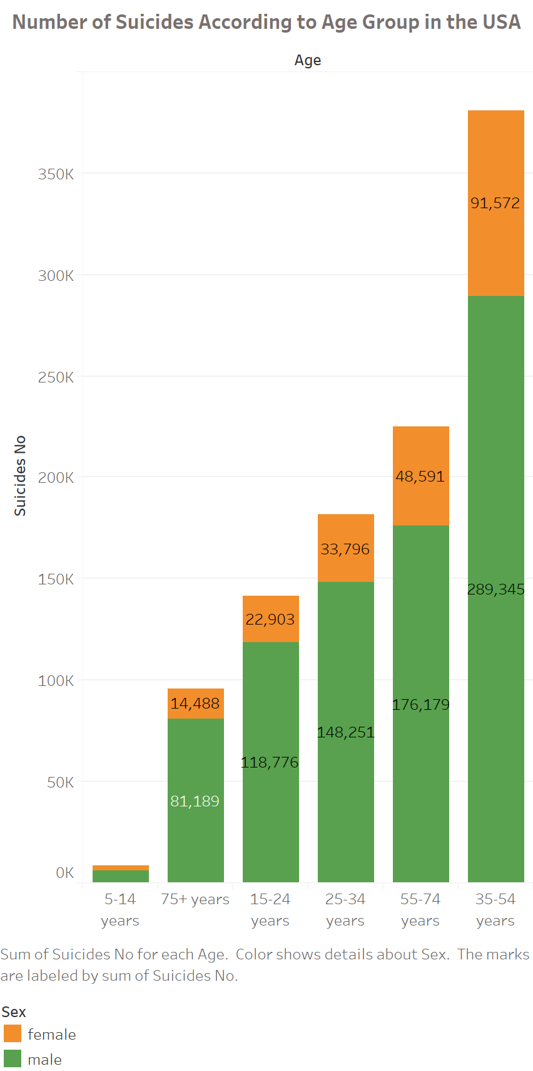

The link of the original dataset is

<https://www.kaggle.com/russellyates88/suicide-rates-overview-1985-to-2016/version/1?select=master.csv>